

SHELL COMMANDS & FILES

ASSIGNMENT #2 FOR OSYS1000: UNIX OPERATING SYSTEM



January 23, 2020

JAMIE LU

W0441213

1) What is the command to list all files in a folder?

ls <folder name> or just lswhen you are already in the folder

2) What is the command to list all files in a folder, including hidden files and all details?

ls -al

3) Assuming that you are in a folder with a subfolder called “Commands”, what is the command to switch to the Commands folder?

cd Commands

4) What is the command to switch to a folder called “Documents” that is parallel to your current folder in the directory structure?

cd ../Documents

5) What is the command to switch to the root of the file system?

cd /

6) What is the command to display the current working directory?

pwd

7) What is the command to display the current system date?

date

8) What is the command to display a calendar of March, 2014?

cal 3 2014

9) What is the command to set the permissions of a file called test.txt to permit full access for all system users?

chmod 777 test.txt

10) What is the command to set the file permissions of test.txt to allow full access for the owner and read access for all other system users?

chmod 744 test.txt

11) What is the command to find the string “Hello” in a text file called text.txt?

grep Hello text.txt

12) What is the command to create an empty file called file1?

touch file1

13) What is the command to display the content of a file called file7?

cat file7

14) What command displays the first few lines of a file called system.log?

head 3 system.log

15) What command displays the last few lines of a file called system.log?

tail 3 system.log

16) What command do you use to get detailed help on a system command, show an example.

man <system command> will give a detailed manual of the specified system command.

Example:

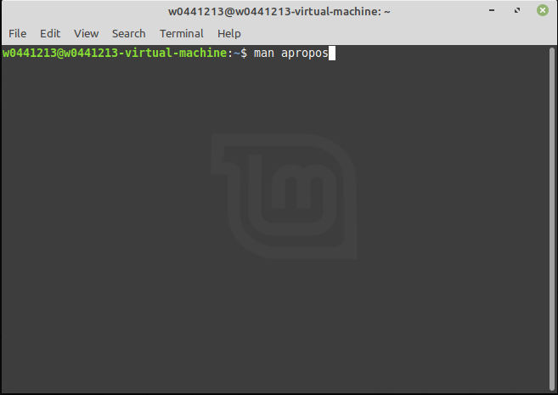

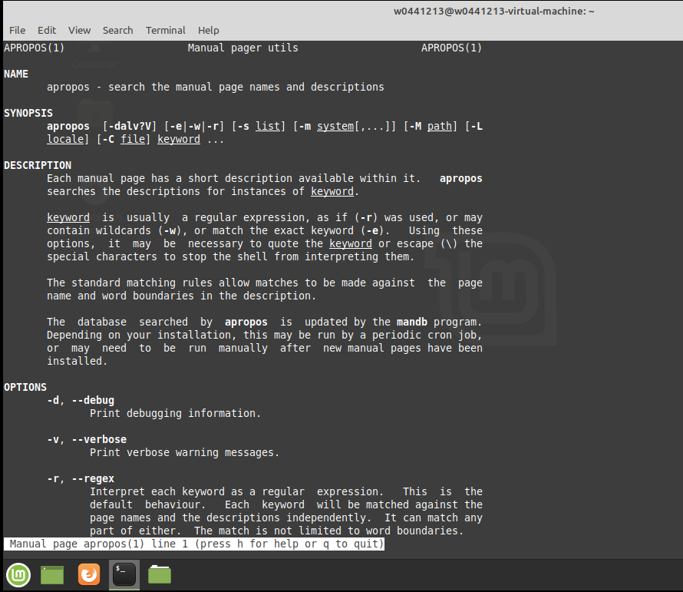

17) What command can you use to help you find system commands related to a topic or subject?

apropos <topic/subject>

18) What is the command to display the contents of a file called fish in paged mode on the screen?

less fish

19) What is the series of commands to display the contents of a folder or directory and send the output to the system command to display the contents in paged mode?

ls \* | less

20) What is the series of commands to display the contents of a directory and send the output to the system command to search for and display all of the entries containing the string “Linux”?

ls | grep Linux \* -|